INSTALLATION INSTRUCTIONS
1) Run the Setup File.
2) Then Connect the UPS USB to the Computer.
3) Open device manager, under "Ports" you will see "CDC-Emulator" or “Serial Port” or a “yellow exclamation mark”. Right click that and select "Update Driver Software".

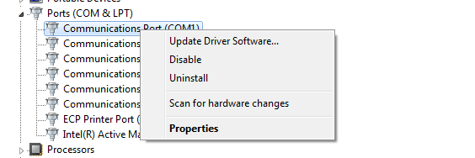
4) On the next screen select "Browse my computer for driver Software".
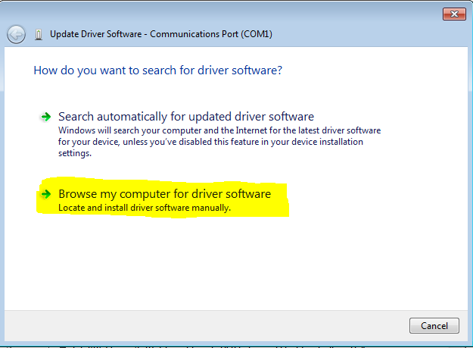
5) Then on the next page Browse to whatever the file Location in set in step 2. Then Click Next.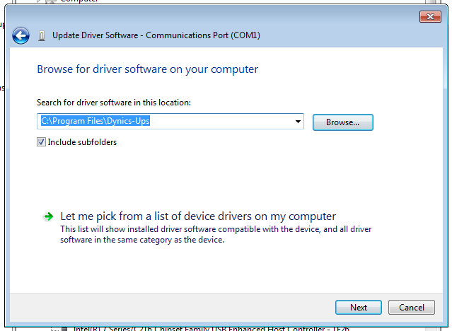

6) The driver will install and the software is ready to use.

