Dynics UPS Software User Guide

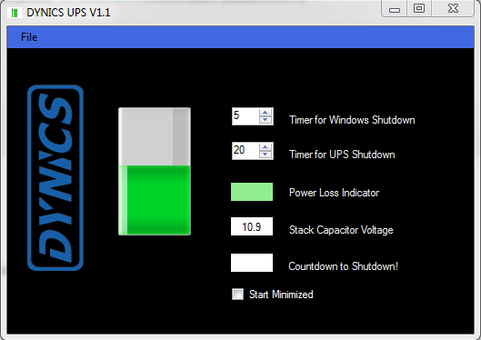
A
D
C
B

The Amount of Charge Left in the UPS(Not fully Charged)

The above figure shows the various components of the UPS Software. The figure shows that the UPS is charged half way.
- You can adjust the Timer for windows to Shutdown. When the power goes out, the Windows will Automatically shut down after the set Timer in seconds.
- This Timer allows you to set a Timer for the UPS to Shutdown once the Power goes out. You can adjust this Timer.
- The power Loss indicator is green when there is Power and turns red when there is Power loss.
- This Field shows the Capacitor Voltage. The UPS Charges to 20V at full capacity.

- The File Menu has an option to ‘Save’ the configuration settings.
- Under Settings, we have the option to activate or De-Activate Screen Brightness

This is the Icon the Windows Tray. You can right Click on this icon to close the software.

